Ideation Phase

Define the Problem Statements

|  |  |
| --- | --- |
| Date | 24 JUNE 2025 |
| Team ID | LTVIP2025TMID52116 |
| Project Name | Cosmetic Insights : Navigating Cosmetics Trends and Consumer Insights with Tableau |
| Maximum Marks | 2 Marks |

**Customer Problem Statement Template:**

Create a problem statement to understand your customer's point of view. The Customer Problem Statement template helps you focus on what matters to create experiences people will love.

A well-articulated customer problem statement allows you and your team to find the ideal solution for the challenges your customers face. Throughout the process, you’ll also be able to empathize with your customers, which helps you better understand how they perceive your product or service.

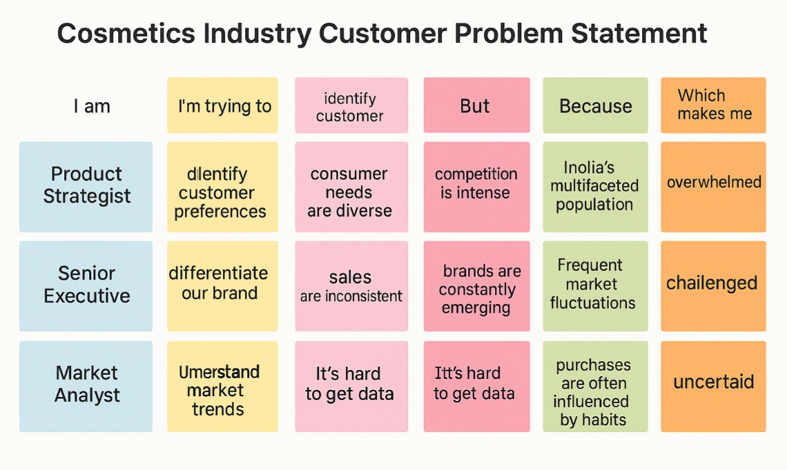

|  |  |  |  |  |  |
| --- | --- | --- | --- | --- | --- |
| **PS ID** | **I am** | **I'm trying to** | **But** | **Because** | **Which makes me feel** |
| PS-1 | a product strategist | identify which cosmetic products drive customer retention in urban India | data is scattered and non-visual | there is no centralized dashboard | unsure about development and launch strategies |
| PS-2 | a marketing lead | compare sales and trends across different cosmetics categories and regions | I can't filter or analyze by region and time accurately | reports are generic and not tailored to cosmetics | frustrated and unsure how to tailor promotions |
| PS-3 | a senior executive | present cosmetic market growth and performance to stakeholders | reports lack compelling visuals and clear narratives | there's no story-driven, visual dashboard | disengaged and ineffective |
| PS-4 | a market analyst | understand how factors like skin type and climate affect product preferences | I can’t explore patterns or correlations easily | tools are outdated and not interactive | stuck and unable to derive insights |